# Result

## Model 1:

train convolutional neural network to classify images with noisy labels

## Model 2:

first use label cleaning procedure, then train the same neural network with edited labels

## Label Cleaning:

Label correction accuracy on the validation set peaked at 60.55%, and the performance on the test set was 60.45%. We believe this to be a good improvement over the benchmark of 39.68% correct labels, which would be the result of simply treating noisy labels as clean labels.

## Evaluation:

Improvement in performance improvement:

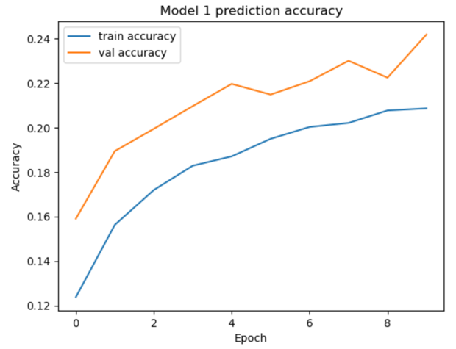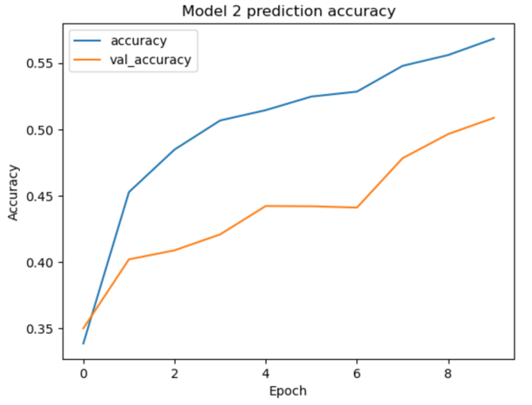

Improvement in running cost tradeoff:

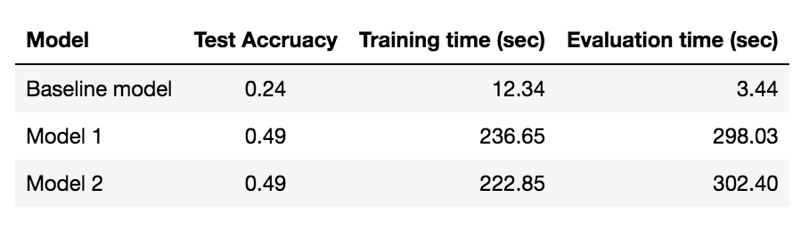

The test accuracy for model 2 is 0.49, the same as model 1. The training time for model 1 is 236.65 seconds, which is 13.8 seconds slower than model 2. And The evaluation time for model 1 is 298.03 seconds, which is 4.37 seconds faster than model 2.